2023

Jon Helge Skjærstein

NTNU student

19.04.2023

The Double Diamond Design Thinking Process and How to Use it

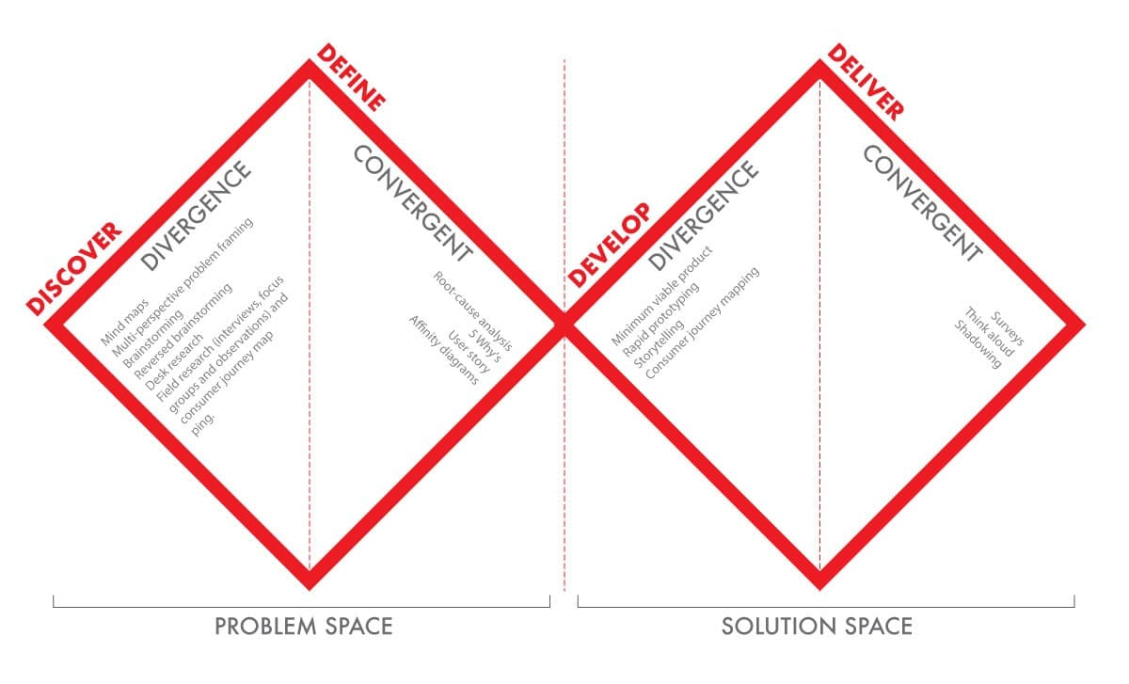

**Innhold**

**Notes, pre words** 2

# **Notes, pre words**

When we work with design we need to be able to work in a creative way, many companies are still locked inside a small creative room where designers do not efficiently contribute to the overall process of the project that they are working on. This is because for businesses design is often looked upon as a tool rather than a strategy in creating good projects. Luckily there have been a change since UX design came to the view for the companies around 2018.

This change from looking at the design as a company tool to integrate design into the strategic ways a company is run did a big change for how the market looks at design as a tool. This new way of working is a big factor in today’s apps websites and more.

We have different methods of working in design thinking process. I will in this document explain and understand how the double-diamond design thinking process works. This particular thinking process method is a very popular if not the most popular one in today’s market.